

Crispy Chicken Sandwich

w/ Pickles

**V: Fish on a Roll**

Tater Tots

Celery & Carrot Sticks Ranch

**NYS Apple Slices**

**NYS Milk**

**OCTOBER 2021**

Elementary School Base Menu

**Mozzarella Cheese Sticks**

**w/ Sauce**

Toss Salad

Mixed Fresh Fruit Salad

**NYS Milk**

***Halloween Treat***

**Mozzarella Cheese Sticks**

**w/ Sauce**

Caesar Salad

Fresh Cantaloupe

**NYS Milk**

Philly Cheese Steak

**V: Fish on a Roll**

Hash Brown

**NYS Apple Slices**

**NYS Milk**

French Toast Sticks w/

**NYS Cheese Stick**

**NYS Home Fries**

*Pumpkin Spice Yogurt*

Fresh Orange Wedges

**NYS Milk**

Warm Ham & Cheese on Pretzel Roll

**V: Fish on a Roll**

Fresh Veggie & Hummus

Grapes

**NYS Milk**

Turkey Hot Dog

**V: Fish Fry**

**NYS Oven Roasted Vegetable**

**NYS Apple**

**NYS Milk**

***NYS THURSDAY***

**Columbus Day**

**No School**

Cheddar Burger

**V: Veggie Cheddar Burger**

Lettuce & Tomato

French Fries

**NYS Apple Slices**

**NYS Milk**

***NYS THURSDAY***

Dinosaur Chicken Nuggets

**V: Fish Sticks**

Smiley Fries

Cucumbers & Ranch Dip

Strawberry Cup

**NYS Milk**

Lasagna

**V: Vegetable Lasagna**

Garlic Breadstick

Broccoli

Applesauce

**NYS Milk**

***Halloween Soft Pretzel***

Tomato Soup

**NYS Cheese Stick**

Fruit of the Day

**NYS Milk**

Chicken & Cheese Quesadilla

**V: Cheese Quesadilla**

Salsa, Sour Cream

Street Corn

Fresh Pear

**NYS Milk**

Loaded Nachos

**V: Cheese Nachos**

Salsa, Sour Cream

Black Beans & Corn

Grapes

**NYS Milk**

Tacos

**V: Fish Tacos**

Black Bean Salsa

Fresh Pear

**NYS Milk**

Grilled Cheese

w/ Tomato Soup

Carrots & Ranch Dip

**NYS Apple**

**NYS Milk**

Cheesy Macaroni and Cheese

**NYS Oven Roasted Vegetable**

Mixed Berries

**NYS Milk**

Popcorn Chicken Bowl

Mashed Potatoes & Gravy

**V: Fish Nuggets**

Corn

Peaches

**NYS Milk**

Cheese Pizza

Tomato & Cucumber Salad

Fresh Honeydew

**NYS Milk**

**Mozzarella Cheese Sticks**

**w/ Sauce**

Caesar Salad

Mixed Fresh Fruit Salad

**NYS Milk**

Turkey Pepperoni Pizza

**V: Cheese Pizza**

Toss Salad

Mixed Grapes

**NYS Milk**

**OCTOBER 2021**

Breakfast Choices & Alternate Lunch Options

**Breakfast Choices:**

**Monday:** Cinnamon Toast Crunch Cereal

**Tuesday:** Multi Grain Muffin

**Wednesday:** Apple Jack Cereal

**Thursday:** Waffles

**Friday:** Bagel with Cream Cheese

**Everyday**: 100% Fruit Juice or Fruit of the Day and Milk

**Alternate Lunch Options:**

Hummus with Pretzel & Crackers & Vegetables (served with fruit, choice of milk)

Yogurt (served with granola bar, fruit/veg, choice of milk)

Chicken Caesar Salad (served with dinner roll, fruit, choice of milk)

Sun Butter & Jelly Sandwich (served with fruit, vegetable, choice of milk)

Sandwich of the Day (served with fruit/veg, choice of milk)

**Sandwich of the Day:**

**Monday:** Turkey & Cheese Wrap

**Tuesday:** Ham & Cheese Sub

**Wednesday:** Grilled Cheese

**Thursday:** Ham & Cheese on Pretzel Roll

**Friday:** Tuna Sub

**Turkey products used for sandwiches**

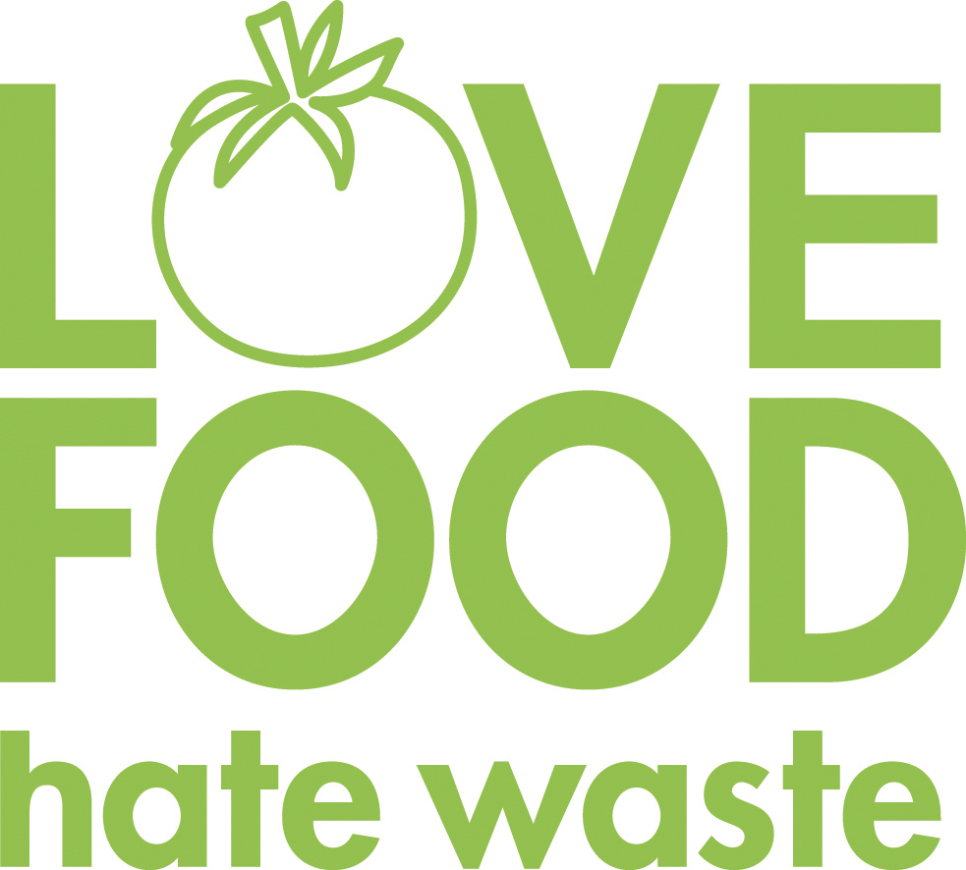

**Our food service department wants to prevent food waste! If there are any items in your school lunch that are prepackaged, remember to pack them up and save them for later. Cheese sticks, apples, Craisins, or fruit cups would be great for an afternoon snack!**

**October Menu Highlights:**

**Check out our *Halloween* inspired meals this month!**

**UPDATE: The USDA extended FREE meals to all students until June 2022. **It remains important that families who believe they may qualify for the Free and Reduced Price Meal program submit an application. We want to be sure that all eligible families are enrolled in this program\*\***

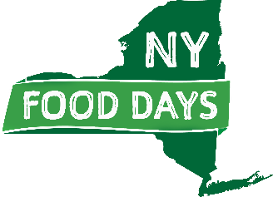

**We are striving to support our New York State food producers. Items highlighted in green are NYS food products.**