

Assorted Pizza

Salad of the Day

Assorted Fruit

NYS Milk

Crispy Chicken Sandwich

Waffle Fries

Celery & Carrot Sticks Ranch

Assorted Fruit

NYS Milk

Assorted Garbage Bread

Salad of the Day

Assorted Fruit

NYS Milk

Chicken & Waffles

Home Fries

Assorted Fruit

NYS Milk

Turkey, Bacon, & Cheddar Panini

Fresh Veggie & Hummus

Assorted Fruit

NYS Milk

**\*Turkey Bacon Used**

Baked Ziti with Beef

Garlic Breadstick

Broccoli

Fruit of the Day

NYS Milk

Chicken Tenders

Biscuit

Tater Tots

Cucumbers & Ranch Dip

Assorted Fruit

NYS Milk

Assorted Pizza

Salad of the Day

Assorted Fruit

NYS Milk

**NYS Cheddar Burger**

Lettuce & Tomato

French Fries

Assorted Fruit

NYS Milk

Grilled Cheese

& Tomato Soup

Assorted Fruit

NYS Milk

French Toast Sticks

Hash Brown

Turkey Sausage

Assorted Fruit

*Pumpkin Spice Yogurt*

NYS Milk

Crispy Chicken BLT

Broccoli

Fruit of the Day

NYS Milk

Cheeseburger

Sweet Potato Fries

Assorted Fruit

NYS Milk

Popcorn Chicken Bowl

Mashed Potatoes & Gravy

Corn

Assorted Fruit

NYS Milk

Assorted Pizza

Salad of the Day

Assorted Fruit

NYS Milk

**OCTOBER 2021**

Watervliet MS/HS Lunch Menu

**Columbus Day**

**No School**

Loaded Tacos

Salsa, Sour Cream

Black Beans and Corn

Fresh Pear

NYS Milk

**\*Turkey Taco Meat Used**

General Tso’s Chicken

Fried Rice

Broccoli

Fruit of the Day

NYS Milk

NYS 100% Beef Hot Dog

NYS French Fries

Assorted Fruit

NYS Milk

Assorted Pizza

Salad of the Day

Assorted Fruit

NYS Milk

Loaded Nachos

Salsa, Sour Cream

Nacho Cheese

Black Beans & Corn

Assorted Fruit

NYS Milk

**OCTOBER 2021**

Breakfast Choices & Alternate Lunch Options

**Alternate Breakfast Choices:**

Bagel with Cream Cheese

Assorted Cereal

Whole Grain Muffin

Fruit: 100% Fruit Juice or Fruit of the Day

Choice of Milk

**Alternate Lunch Options:**

Hummus with Pita Chips, Vegetables (served with fruit, choice of milk)

Salad of the Day (served with dinner roll, fruit, choice of milk)

Chicken & Cheese Quesadilla (served with a vegetable, fruit, choice of milk)

Cheese Pizza

Sun Butter & Jelly

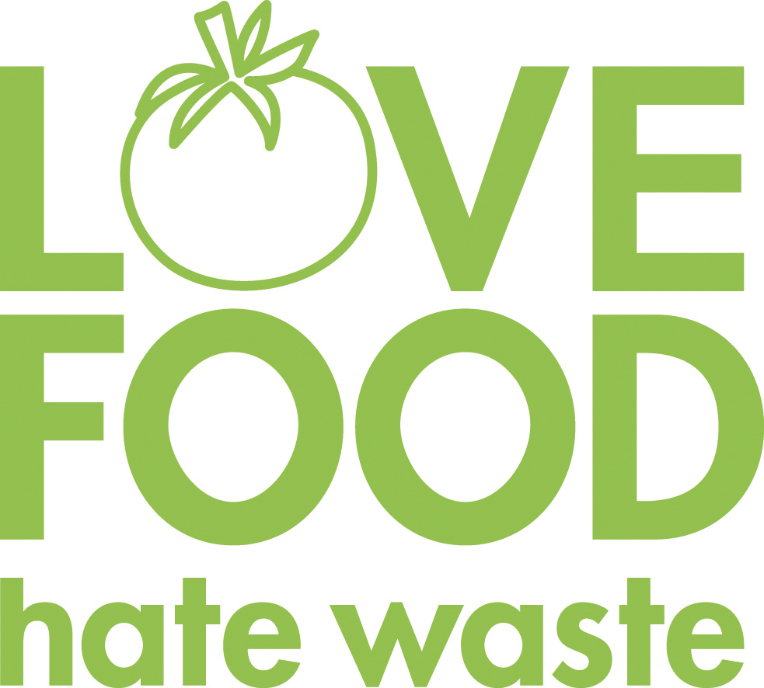

**Our food service department wants to prevent food waste! If there are any items in your school lunch that are prepackaged, remember to pack them up and save them for later. Cheese sticks, apples, Craisins, or fruit cups would be great for an afternoon snack!**

**October Menu Highlights:**

**Check out our *Halloween* inspired meals this month!**

**UPDATE: The USDA extended FREE meals to all students until June 2022. **It remains important that families who believe they may qualify for the Free and Reduced Price Meal program submit an application. We want to be sure that all eligible families are enrolled in this program\*\***

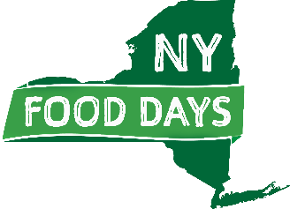

**We are striving to support our New York State food producers. Items highlighted in green are NYS food products.**

**Breakfast Choices:**

Bagel with Cream Cheese

Assorted Cereal

Whole Grain Muffin

Fruit: 100% Fruit Juice or Fruit of the Day

Choice of Milk

**Alternate Lunch Options:**

Hummus with Pita Chips & Vegetables (served with fruit, choice of milk)

Yogurt (served with granola bar, fruit/veg, choice of milk)

Chef Salad (served with dinner roll, fruit, choice of milk)

Sandwich of the Day (served with fruit/veg, choice of milk)

**Sandwich of the Day:**

**Monday:** Turkey & Cheese Wrap

**Tuesday:** Ham & Cheese Sub

**Wednesday:** Grilled Cheese

**Thursday:** Ham & Cheese on Pretzel Roll

**Friday:** Turkey & Cheese Sub

**Sun butter & jelly sandwich available upon request**

**Turkey products used for sandwiches**



**Our food service department wants to prevent food waste! If there are any items in your school lunch that are prepackaged, remember to pack them up and save them for later. Cheese sticks, apples, Craisins, or fruit cups would be great for an afternoon snack!**

**October Menu Highlights:**

**Check out *Halloween* inspired meals this month!**

**UPDATE: The USDA extended FREE meals to all students until June 2022. **It remains important that families who believe they may qualify for the Free and Reduced Price Meal program submit an application. We want to be sure that all eligible families are enrolled in this program\*\***



**We are striving to support our New York State food producers. Items highlighted in green are NYS food products.**